ORDER FORM

Handheld rear support harness
Name:
Address (Street, City, State/Zip, Country):
Phone: |  | Email:
Pet Name: |  | dog, cat  (underline the correct) | Other:
Breed: | Weight: | Age: | Sex:
Comments:

All measurements have to shoot the pet in a standing position. Use a metal tape and a soft tape. Ask a friend or family member to help you take your measurements. One person should support the pet under the belly of a towel, if it was a problem with the rear legs or under the chest if the problem is with the front legs, and hold it in the right position all the time while the other takes measures. Please do not make allowances! Submit the completed form to email frakishtak@gmail.com

Select the support you need
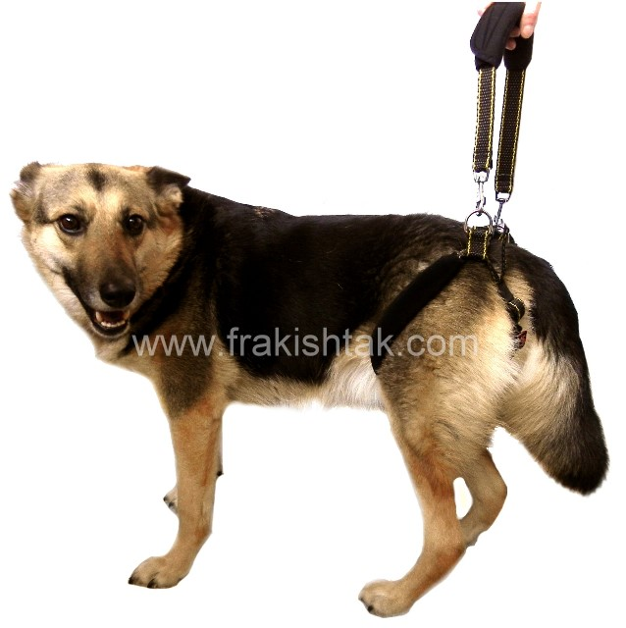 | 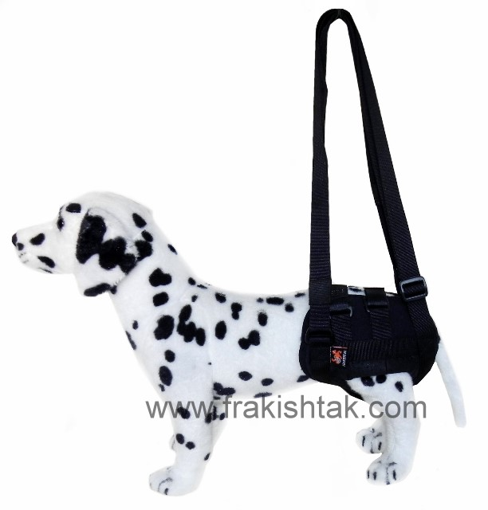
X | X

1.  hip girth | 